SET – 1
Maven Project:
Step 1: mvn archetype:generate
Step 2: quickstart (filter)
Step 3: Type the same number shown in terminal (Example: 134)
Step 4: Pick the version shown in terminal (Example: 9)
Step 5: Fill GroupID: com.example (Constant for all questions), ArchtypeID: (Any folder name), Enter until Y and Enter until Build Succes.
Step 6: Open the folder generated
Step 7: git init
Step 8: git add . (Or add each file separately)
Step 9: git commit -m "Added App.java and AppTest.java"
Step 10: git remote add origin https://github.com/HarithaNivrithi/Agile-Set-A.git (Git Repo)
Step 11: git branch -M main
Step 12: git push -u origin main
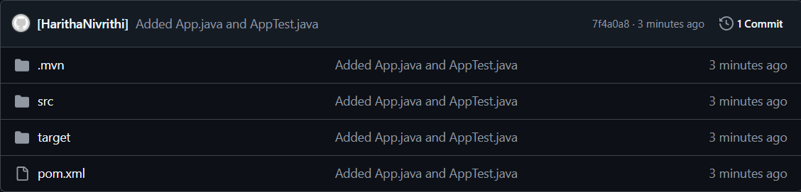
Step 13: Modify App.java, AppTest.java and pom.xml (get code from any AI)
Step 14: git add .
Step 15: git commit -m "Modified Code"
Step 16: git push
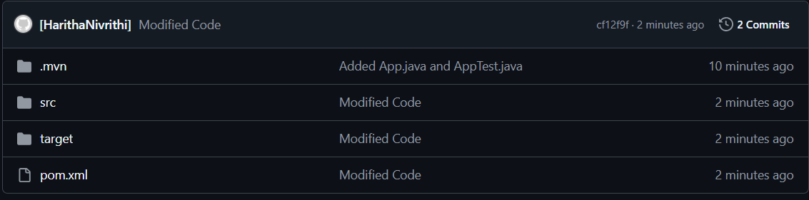
Step 17: mvn clean test (Must get BUILD SUCCESS, add the ss in the doc. With this Maven Project creation is done)
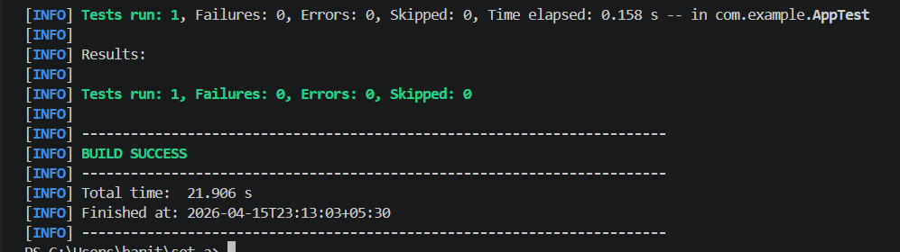
Jenkins Pipeline:
Step 18: Install git, maven, pipeline (also blue ocean), docker, kubernetes plugins (Settings -> Plugins -> Available Plugins -> Search) (Install maven, docker, Kubernetes based on your question)
Step 19: New Item -> Create Pipeline Job
Step 20: Paste Pipeline Script
Sample Pipeline Script: (Use for any problem)
pipeline {
agent any

tools {
maven 'Maven-3'
}

stages {

stage('Checkout Git') {
steps {
git branch: 'main',
url: 'https://github.com/HarithaNivrithi/Agile-Set-A.git'
}
}

stage('Build and Test') {
steps {
bat 'mvn clean test'
}
}
}
}

Step 21: Build

